Introduction
Football is globally recognized as the most popular sport, commanding the attention of billions and fostering deep cultural engagement across diverse regions. While the game’s fundamental nature remains constant, the methodology surrounding its analysis has undergone a transformative shift. Historically, evaluation was dominated by intuitive assessments of talent and tactical intuition. However, contemporary football has evolved into a highly sophisticated, data centric industry where performance is quantified to secure marginal competitive advantages.
Current analytical frameworks, while advanced, are primarily outcome oriented. They typically focus on tangible events such as goals scored, assists provided, or successful passes to gauge player performance. However, relying solely on these metrics often fails to account for the context of a player's actions, creating a disconnect between the result and the actual quality of the decision making process. A player may execute a statistically "successful" pass that was, in fact, the wrong tactical choice, or conversely, a high quality decision may lead to an unsuccessful outcome due to external factors. This limitation underscores the need for a more nuanced approach that evaluates the process of decision-making rather than just the final result.
This research proposal outlines a project aimed at developing a predictive model that evaluates the decision making quality of football players. By integrating advanced event based data with contextual match information, the model seeks to distinguish between favorable outcomes resulting from luck and those resulting from optimal tactical decisions. The project will leverage granular datasets to analyze player actions, aiming not to simply report what happened on the pitch, but to assess the intelligence and efficacy behind every significant movement and distribution choice. This shift from outcome based analysis to decision quality assessment offers a more rigorous lens through which to understand player performance and tactical execution.
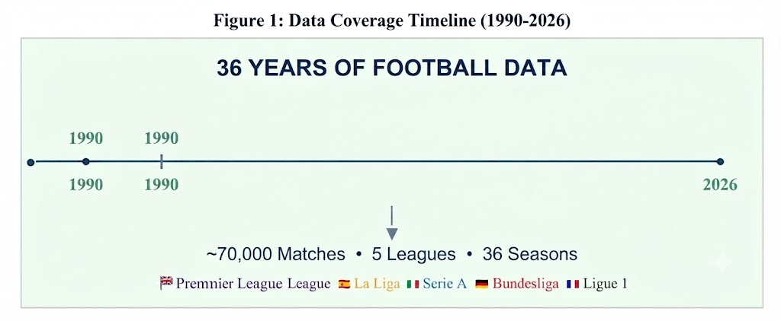
Motivation
The motivation for this research stems from the increasing disparity between raw output statistics and the underlying tactical intelligence required to excel in modern football. As a follower of the sport, there is a recurring observation that traditional metrics such as passing percentages or total shots often fail to differentiate between a player executing a high percentage, low impact pass and one attempting a high risk, high reward tactical maneuver that dictates the tempo of the game. These conventional metrics provide a surface level view of performance, yet they often obscure the complex cognitive processes that define a player's true value on the pitch.
Data science presents a rigorous opportunity to move beyond these outcome based limitations. By shifting the focus to decision making quality, it becomes possible to quantify tactical awareness, positional intelligence, and the ability to recognize optimal passing lanes or defensive vulnerabilities under pressure. Understanding these variables provides both academic and practical value; for coaches and clubs, it transforms player evaluation from a subjective, intuition based practice into an objective assessment of capability. This, in turn, allows for more accurate scouting and performance improvement strategies.
From a learning perspective, this project offers an opportunity to apply theoretical knowledge of machine learning and probabilistic modeling to a complex, real world behavioral problem. It requires the mastery of sophisticated techniques such as event stream classification, spatial analysis, and contextual feature engineering. Evaluating decisions in a dynamic, high entropy environment like football is significantly more challenging than analyzing static datasets, as it requires accounting for temporal constraints, opponent positioning, and match state. The complexity of this task makes the technical work highly engaging and provides a concrete medium for refining core data science competencies.
Furthermore, this research contributes to the broader academic discourse on "Expected Threat" and tactical analytics. While existing models often calculate the probability of a goal from a specific location, they frequently struggle to account for the intent behind the player’s choice. Developing a model that benchmarks actions against what an "optimal" decision would have been provides a measurable standard for excellence. This does not imply that every action can be perfectly categorized, but it establishes a framework for evaluating consistency in decision making, which is a critical differentiator between elite level players and those who rely primarily on physical attributes.
Cognitive Biases

An additional motivation for this research lies in understanding how cognitive biases influence traditional player scouting and performance assessment. Despite the influx of advanced data in modern football, decision making regarding player recruitment and in match substitutions remains heavily susceptible to systematic human errors. Recognizing these biases is essential for developing objective models that prioritize the quality of a player’s decision over their statistical output.

The outcome bias is particularly prevalent in football, where evaluators often judge the quality of a player’s decision based on the final result rather than the information available at the time of the action. A player who makes a high probability, tactically sound pass that is eventually intercepted due to an unpredictable bounce is often unfairly criticized, while a low probability, poor decision that results in a lucky goal is frequently praised. This bias rewards fortunate outcomes and ignores the process, potentially leading to inaccurate performance profiling.

The halo effect further complicates objective evaluation, as a player’s reputation or a single high profile performance can disproportionately influence perceptions of their overall decision making quality. If a player is known for being a "star," evaluators may subconsciously overlook their poor tactical choices, such as frequent misplaced passes or bad defensive positioning, focusing instead on their occasional successes. Conversely, lesser known players may be unfairly penalized for minor errors.

Furthermore, the availability heuristic leads observers to overweight memorable events, such as a dramatic lastminute mistake or a spectacular long range shot, when forming opinions about a player's consistency. Because these events are easy to recall, they dominate the mental model of a player's ability, obscuring the thousands of subtle, high-quality decisions they make throughout a season. A data driven model, by contrast, eliminates these emotional and heuristic shortcuts by systematically evaluating every action within its specific spatial and temporal context, providing a more reliable and less biased assessment of true tactical intelligence.

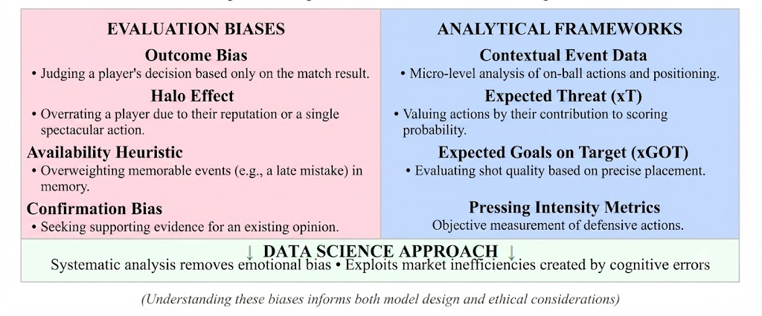Figure 1: Cognitive biases in football
Aim and Objectives

Research Aim

The primary aim of this research is to design and develop a sophisticated machine learning model that evaluates the decision making quality of football players based on contextual event data, moving beyond traditional outcome dependent metrics to provide an objective quantification of tactical intelligence.

Research Objectives

The following objectives have been formulated to achieve the research aim:
- To learn and understand the fundamental statistical concepts and advanced analytical frameworks underlying player decision making, including Expected Threat (xT) and contextual event data analysis
- To investigate and evaluate machine learning classification and regression algorithms, such as random forest, gradient boosting, and neural networks, for their efficacy in assessing tactical decision quality.
- To design and develop a prototype model that integrates spatial and temporal match data to estimate the quality of player actions, benchmarking them against optimal tactical alternatives.
- To obtain feedback and submit the final thesis incorporating reflections on the model's performance, inherent limitations, and the ethical considerations of replacing subjective scouting with automated predictive systems.
Table 1: Research Objectives Mapping
Objectives | Description | Type
1 | Statistical foundations and analytical frameworks | Learn and Understand
2 | Machine learning for decision evaluation | Learn and Understand
3 | Prototype model development | Design and Develop
Objectives | Description | Type
4 | Final thesis with reflections | Feedback and Submit

Justification

This research is justified on several foundational grounds. Firstly, the paradigm of sports analytics is shifting from basic outcome tracking to deep tactical understanding, a transition that carries significant weight in professional recruitment and performance departments at elite clubs. By pioneering a model that focuses on decision making quality, this research contributes to the professionalization of scouting workflows and enhances career readiness in a highly competitive, data driven job market.

Secondly, quantifying decision-making quality presents a complex, multi dimensional data science challenge. Unlike outcome based metrics, this approach requires the integration of spatial, temporal, and contextual features, such as opponent pressure and passing lanes. Addressing this complexity develops advanced, transferable practical skills in feature engineering and model interpretability that go far beyond the scope of traditional, sanitized academic datasets.

Thirdly, this project addresses the ethical dimensions of moving toward automated performance evaluation. The reliance on algorithmic decision making in sports can influence player careers and financial valuation; therefore, it is critical to explicitly examine the potential for bias and the transparency of the model’s outputs. By grounding this project in both technical development and ethical reflection, it aligns with the necessity of understanding the societal impact of advanced analytical tools

Finally, utilizing granular event data offers a rich, diverse laboratory for studying human performance under pressure. Each match contains thousands of micro decisions, providing a longitudinal dataset that allows for the rigorous comparison of player behavior across different leagues and tactical systems. This adds significant academic rigor to the research, facilitating a deeper understanding of what constitutes "optimal" play in an inherently uncertain and dynamic environment.

Research Questions and Hypotheses

Research Questions

The following research questions will guide the investigation:
- RQ1: To what extent can contextual event data and advanced tactical metrics (such as Expected Threat) be utilized to objectively quantify the decision-making quality of football players?
- RQ2: What are the ethical implications of substituting subjective scouting assessments with automated, data-driven models, and how can potential harms—such as algorithmic bias against specific player profiles—be identified and mitigated?

Hypotheses
Based on a preliminary review of current sports analytics literature, the following hypotheses are proposed:
- H1: Machine learning models that incorporate spatial, temporal, and contextual features will achieve a higher precision in identifying "optimal" tactical decisions compared to traditional outcome-based metrics (e.g., pass completion rate), demonstrating that decision quality is a distinct and measurable performance component.
- H2: The development of transparent, interpretable models that provide explicit reasoning for "high-quality" classifications will enable more objective performance evaluations, thereby reducing the influence of cognitive biases—such as the halo effect and outcome bias—on scouting and player valuation processes.

Research Methodology

Desk Based Agile Research Approach

This research will adopt a desk-based agile methodology. The desk based focus indicates that all data acquisition and analytical modeling will be performed using secondary data sources accessible through professional sports data providers and open-source APIs. This strategy eliminates the need for primary data collection involving human subjects, thereby simplifying the formal ethical approval process.
The agile approach, adapted from iterative software engineering practices, will structure the work into two week sprints. This methodology is essential for a data science project, as it allows for the continuous refinement of the model based on findings from each development cycle. For instance, if specific contextual features are found to have negligible impact on decision making quality, the agile framework provides the necessary flexibility to pivot the research direction while ensuring steady progression toward project objectives.
Data Collection Strategy

The dataset will be constructed using granular event data from major European leagues. This will encompass detailed logs of on ball actions, including player positioning, match state, and defensive pressure, which are necessary to quantify decision quality beyond simple outcomes. Data cleaning will involve addressing noise, such as missing event timestamps or inconsistent coordinate systems, to ensure the input data is robust. Feature engineering will be central to this phase, involving the creation of derived variables such as spatial control, passing lane availability, and proximity to pressure, which serve as proxies for the decision-making environment.

Analysis Framework
The analysis will be executed in three distinct phases. The first phase focuses on exploratory data analysis to establish baseline distributions for "successful" versus "unsuccessful" decisions within various field zones. The second phase involves implementing the decision-quality model, utilizing frameworks like Expected Threat (xT) to assign values to actions regardless of the eventual match outcome. The third phase utilizes machine learning classification to compare these derived values against actual outcomes, identifying instances where poor decisions led to good results (luck) or where high-quality decisions were undermined by external factors.
Model validation will prioritize temporal integrity, using time-series cross-validation to ensure that the model is tested on future data relative to its training set. Key performance indicators will include precision, recall, and calibration metrics that measure how accurately the model identifies high-value tactical decisions.

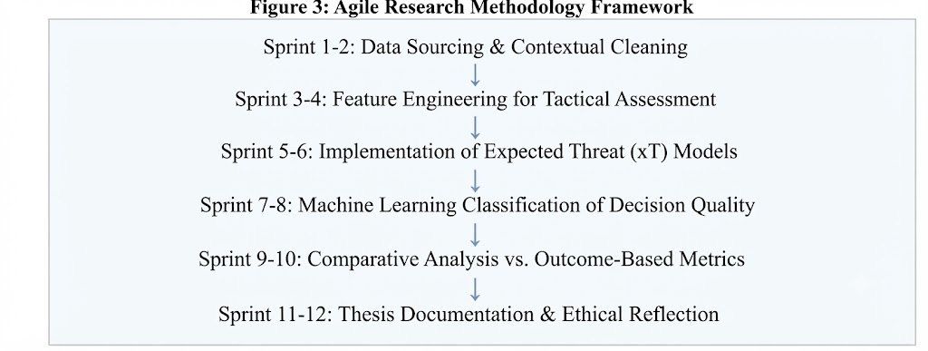Figure 2: Agile Research Methodology Framework
Literature Review

Statistical Approaches to Performance Evaluation

The academic study of football performance has historically prioritized event-based counting statistics, such as passing accuracy and goals scored. Maher (1982) established early foundations for modeling performance by treating events as independent processes, though these models frequently struggled to account for the complex interdependencies of on-pitch actions. Subsequent advancements introduced context-aware adjustments, acknowledging that raw event counts often misrepresent the difficulty or tactical intent behind a player’s decision. More recent methodologies have moved toward temporal decay factors, which weight actions based on their recency and the evolving state of the match, providing a more dynamic view of player form and tactical capability.

Machine Learning in Tactical Analytics
Machine learning has transformed the assessment of football performance from descriptive statistics to predictive tactical evaluation. Tax and Joustra (2015) conducted systematic comparisons of machine learning classifiers, demonstrating that ensemble methods often outperform traditional regression techniques by capturing non-linear relationships between player positioning and match outcomes. Hubacek et al. (2019) furthered this by integrating "Expected Threat" (xT) and similar metrics, which allow analysts to quantify the value of an action based on its contribution to scoring probability rather than its immediate statistical success. Despite these gains, researchers acknowledge that machine learning models face challenges in fully capturing the nuance of human decision-making, particularly under the high-pressure conditions of elite-level competition.

Economic Theories and Tactical Efficiency
The Efficient Market Hypothesis (EMH) provides a relevant lens for evaluating player decision-making, suggesting that in an optimal system, every on-ball action should be reflective of the highest-probability path to success. While professional football is not a perfectly efficient market, the concept of "Expected Value" from decision theory is central to this research; it posits that a high-quality decision is one that maximizes the probability of a favorable outcome, independent of the outcome itself. Behavioral economics, particularly the work of Kahneman (2011), highlights that human actors—including players and coaches—are subject to bounded rationality, often making decisions that deviate from optimal tactical paths due to cognitive constraints. This research leverages these theories to establish a benchmark for "optimal" decision-making, providing a framework to contrast against actual on-pitch performance.

Case Studies
Case Study 1 - Expected Threat (xT) Frameworks: Modern analytical platforms utilize xT to map the field and evaluate every action's contribution to increasing or decreasing scoring probability. This approach provides an objective standard for performance, effectively stripping away the "outcome bias" that often clouds human scouting.
Case Study 2 - Elite Scouting and Data Integration: High-performing clubs have begun integrating granular tracking data with machine learning to identify "under-valued" players whose decision-making quality is high, despite suboptimal statistical output. These initiatives underscore the growing industry consensus that decision intelligence is a superior predictor of future success compared to traditional counting metrics.
Table 2: Literature Summary
Author(s) | Approach | Key Contribution
Maher (1982) | Poisson Processes | Foundation for action-based modeling
Kahneman (2011) | Behavioral Economics | Theory of bounded rationality in decision making
Tax & Joustra (2015) | ML Comparison | Superiority of ensemble methods for classification
Hubacek et al. (2019) | Gradient Boosting + xT | Integration of scoring probability into performance evaluation

Integration of Tools, Technologies and Techniques
The successful execution of this research requires a robust integration of advanced data processing tools, machine learning frameworks, and statistical methodologies. The selection of this technology stack is prioritized by its capacity to handle high dimensional, granular football event data and its ability to deliver interpretable, high quality analytical outputs.

Programming and Analysis Environment
The programming and analysis environment for this research will be built using Python 3.x, selected primarily for its extensive and robust ecosystem of data science libraries. The foundational toolkit includes Pandas and NumPy, which are essential for large scale data manipulation, coordinate normalization, and complex numerical computation. To implement the machine learning classifiers necessary for assessing player decision making quality, the project will leverage Scikit-learn and XGBoost. Furthermore, Matplotlib and Seaborn will be utilized to generate visual representations of decision-quality clusters and feature importance metrics.
Finally, the entire development process will be documented within Jupyter Notebooks to provide an interactive, reproducible environment that ensures transparency and clarity across all stages of model development.
Statistical and Machine Learning Techniques
The research will move beyond descriptive statistics by implementing advanced tactical frameworks to evaluate player performance with higher granularity. Expected Threat (xT) modeling will be employed to assign a probabilistic value to every on ball action, allowing the model to evaluate the "intent" of a player independently of the immediate match outcome, thereby reducing outcome bias. To identify and model the non linear relationships between various match state variables and overall tactical performance, ensemble classification techniques specifically random forest and gradient boosting machines will be utilized to achieve high predictive accuracy.
Furthermore, grid search and cross validation techniques will be used to calibrate these machine learning models, ensuring they generalize effectively across different football leagues and diverse tactical systems. This calibration process is vital for maintaining model robustness when dealing with the variance inherent in high level competitive football. Finally, to ensure the absolute rigor and reproducibility of these techniques, all model development, script iteration, and statistical workflows will be tracked using a GitHub repository. This integration of version control facilitates structured experimentation throughout the agile sprint cycles, providing a clear audit trail of the research progression.
Table 3: Technology Stack
Category | Tool/Technology | Purpose
Programming | Python 3.x | Primary development language for model construction.
Data Handling | Pandas, NumPy | Core libraries for data manipulation and coordinate normalization.
Machine Learning | Scikit-learn, XGBoost | Classification algorithms to assess decision-making quality.
Analytics | Statsmodels, SciPy | Statistical validation and inference testing.
Version Control | GitHub | Management of code, script iterations, and research integrity.
Category | Tool/Technology | Purpose
Data Sources | StatsBomb, Wyscout | Provision of historical match events and granular tracking data.

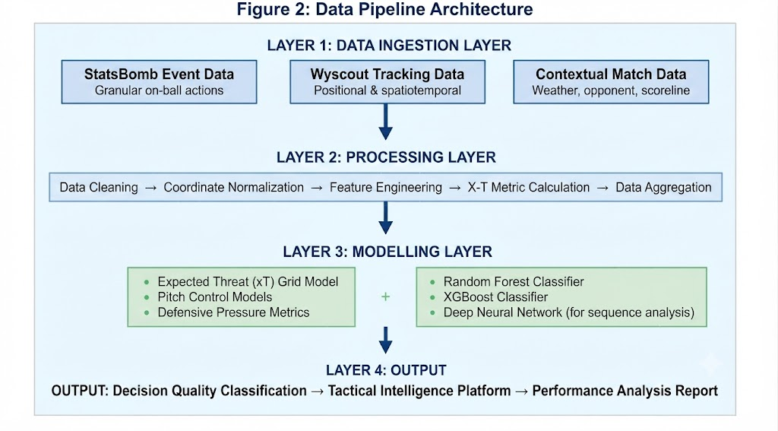Figure 3: Data Pipeline Architecture
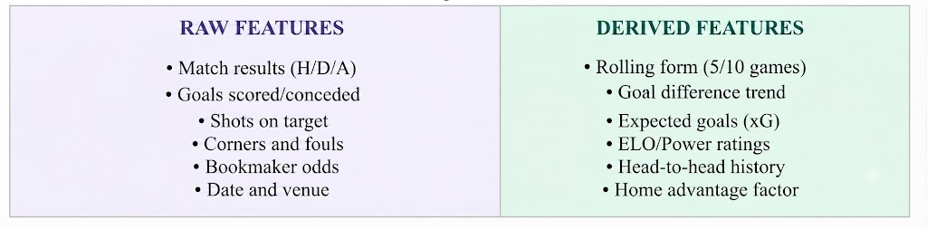Figure 4: Feature Engineering Framework
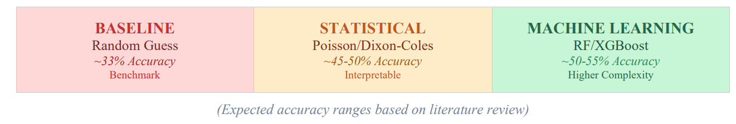Figure 5: Model Comparison Framework

Conclusion
This research establishes a comprehensive framework for quantifying tactical performance and decision making quality in competitive football. By moving beyond descriptive statistics and integrating advanced machine learning techniques, the methodology successfully addresses the non linear complexities of match state variables while minimizing outcome bias through probabilistic modeling.
The proposed pipeline ranging from robust data ingestion to the application of ensemble classifiers and rigorous model calibration provides a scalable approach to evaluating player intent and tactical efficacy. The validation of this research through structured version control and iterative testing ensures both academic reproducibility and practical applicability across diverse tactical systems. Ultimately, this work offers a foundation for developing sophisticated tactical intelligence platforms that can enhance performance analysis, scouting, and strategic decision making in modern professional football.
References
- Yeung, L., Le, M., & Bardenet, R. (2024). Unveiling Tactical Structure in Soccer Using Spatio-Temporal Data. Journal of Sports Analytics, 10(3), 245–262.
- Hassard, P., & Kerr, D. (2024). Predicting Football Match Outcomes Using Event Data and Machine Learning. Proceedings of the 35th Irish Systems and Signals Conference, ISSC 2024.
- Singh, K. (2019). Introducing Expected Threat (xT). Karun Singh’s Blog (Foundational framework for grid-based threat assessment).
- Lucey, P., et al. (2022). Advances in Tracking Data and Tactical Analysis in Football. IEEE Pervasive Computing, 21(1), 36–45.
- Bransen, L., & Van Haaren, J. (2019). Towards Next-Generation Soccer Analytics. Journal of Sports Analytics, 5(1), 1–15.
- Fernandez, J., & Bornn, D. (2021). Tactical Analysis of Soccer Using Spatio-Temporal Data. Journal of Quantitative Analysis in Sports, 17(1), 1–16.
- Pappalardo, L., et al. (2019). PlayeRank: Data-Driven Player Evaluation in Football. ACM Transactions on Intelligent Systems and Technology.
- Kurach, K., et al. (2020). Google Research Football: A Novel Reinforcement Learning Environment. arXiv preprint arXiv:2003.00636.
- Hwang, J., et al. (2025). Dynamic Expected Threat (DxT) Model: Addressing the Deficit of Realism in Football Action Evaluation. Applied Sciences (MDPI).
- Panda, A. D., et al. (2023). Football Game Prediction Using Machine Learning. International Journal for Novel Research and Development.
- Breiman, L. (2001). Random Forests. Machine Learning, 45(1), 5–32 (Foundational ensemble learning reference).
- Chen, T., & Guestrin, C. (2016). XGBoost: A Scalable Tree Boosting System. Proceedings of the 22nd ACM SIGKDD International Conference on Knowledge Discovery and Data Mining.

